We know this is a busy time for you.
Thank you for your help!

Please read this before starting:
- It usually takes about 15-20 minutes to fill out the survey. We will send you a Target or Amazon gift card when we receive your completed survey.
- It’s your choice whether or not to do the survey.
- Answering the survey questions will not affect your health care or any benefits you may get.
- You can skip questions you don’t want to answer.
- We will not connect your name and contact information to your survey answers.
- Using a special code, we will connect survey answers to information from birth certificates and other sources.
- Information that identifies you will be kept secure. We do not ask about immigration status. Protecting your personal information is our highest priority.
- If you have any questions about the survey, please call 1-888-650-2649 or email info@MIHAforCA.org.

- For information on your rights as a research participant, please call the Committee for the Protection of Human Subjects at (916) 651-5599.
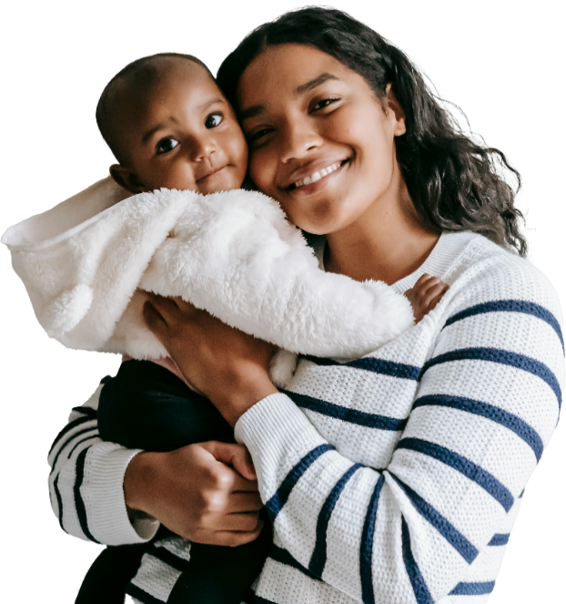

Here’s how to fill out the survey:
- Please try to answer each question.
- Using a blue or black pen, answer each question by checking the box or writing a number or a few words on the line.
- Never check more than one box, except where it says “Check ALL that apply.”
- Sometimes we ask you to skip a question. An arrow will tell you what question to answer next, like this:
  - □ Yes à Skip to question 1
  - □ No
- If none of the boxes are right for you, please check the one that fits you best.
- If you need help with the survey or decide you want to do it by telephone, please call one of our interviewers at 1-888-650-2649.
- If you have questions about the survey, you can email us at info@MIHAforCA.org.
Be sure to fill out the last page of the survey, which asks for your mailing address so we can send you a gift card to say, “thank you.” Then please mail this survey back to us in the enclosed postage-paid envelope. No stamps are needed.
In our thank you note, we’ll share more details about how this MIHA survey helps support the health of families in California and offer you a way for you to stay informed about the survey, if you want.

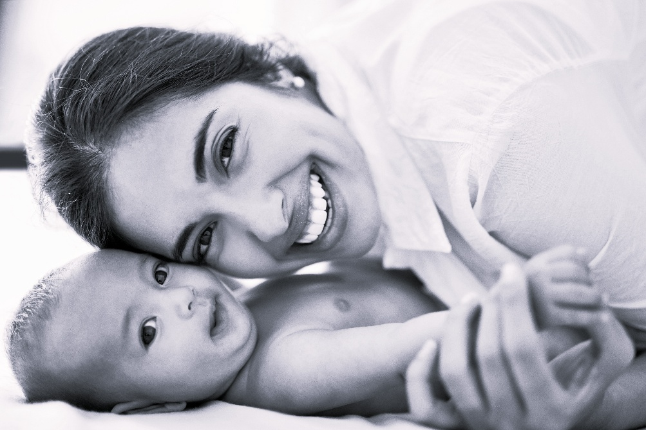

- What is today's date?
,
month day year
- When was your most recent baby born?
,
month day year

These first questions are about the time just before you got pregnant with your baby who was just born.
Just before you got pregnant, did you have a particular doctor, nurse, or clinic that you usually went to if you wanted health care?
  - □ Yes
  - □ No
How would you rate your health just before you got pregnant?
  - □ Excellent
  - □ Very good
  - □ Good
  - □ Fair
  - □ Poor
During the month before you got pregnant, did you have Medi-Cal, private insurance, or some other health insurance plan for your own health care, or were you uninsured?
Check ALL that apply.
  - □ Medi-Cal
  - □ A health plan paid for by Medi-Cal
  - (Name of plan: ______________________)
  - □ Private insurance (paid for by me, someone else, or through a job)
(Name of plan: ______________________)
  - □ Other
(Name of plan: ______________________)
  - □ I did not have Medi-Cal or any other health insurance during the month before I got pregnant
- During the month before you got pregnant with your new baby, how many times a week did you take a multivitamin, a prenatal vitamin, or a folic acid vitamin?
  - □ I didn’t take a multivitamin, prenatal vitamin, or folic acid vitamin in the month before I got pregnant
  - □ 1 to 3 times a week
  - □ 4 to 6 times a week
  - □ Every day of the week
The PreMA is a short, 8-question health quiz some people take on their own before becoming pregnant. The PreMA can be done on paper or online from a computer or smartphone. It’s not given to you at a doctor’s office. Did you take the PreMA quiz yourself before you got pregnant?
  - □ Yes
  - □ No
  - □ I do not remember
Before you got pregnant, did a doctor, nurse or other health care worker ever tell you that you had any of the following health conditions?
 | Yes | No
Diabetes (high blood sugar) | □ | □
Hypertension (high blood pressure) | □ | □
Asthma | □ | □
Depression | □ | □

Now, we have a few questions about your experiences when you were pregnant with your baby who was just born.
During your most recent pregnancy, did you have someone you could turn to if you needed practical help, like getting a ride somewhere, or help with shopping or cooking a meal?
  - □ Yes
  - □ No
During your most recent pregnancy, did you have someone you could turn to if you needed someone to comfort or listen to you?
  - □ Yes
  - □ No

- During your most recent pregnancy, were you given information about “warning signs” you should watch for during and after your pregnancy that require medical care right away? Some of these warning signs include fever, a headache that will not go away or gets worse, severe belly or chest pain, or trouble breathing.
  - □ Yes, I was given information about warning signs
  - □ No, I was not given information about warning signs

- During your most recent pregnancy, did you visit a dentist, dental clinic, or get dental care at any other health clinic?
  - □ Yes
  - □ No

During your most recent pregnancy, did you get a flu shot?
  - □ Yes
  - □ No

- During your most recent pregnancy, did you receive a Tdap vaccination or shot? A Tdap vaccination is a shot that protects against tetanus, diphtheria, and pertussis (whooping cough).
  - □ Yes, I got a Tdap shot during my pregnancy
  - □ No, but I got a Tdap shot in the hospital after I delivered
  - □ No, I did not get a Tdap shot
  - □ I do not remember

The next few questions are about your feelings and experiences when you were pregnant with your baby who was just born.
During your pregnancy, how often did you feel down, depressed, or hopeless?
  - □ Always
  - □ Often
  - □ Sometimes
  - □ Rarely
  - □ Never

During your pregnancy, how often did you have little interest or little pleasure in doing things you usually enjoyed?
  - □ Always
  - □ Often
  - □ Sometimes
  - □ Rarely
  - □ Never
During your pregnancy, how often did you feel nervous, anxious, or on edge?
  - □ Always
  - □ Often
  - □ Sometimes
  - □ Rarely
  - □ Never
During your pregnancy, how often were you not able to stop or control worrying?
  - □ Always
  - □ Often
  - □ Sometimes
  - □ Rarely
  - □ Never

- During your pregnancy, did you fill out a form or were you asked a series of questions from a doctor, nurse, social worker, or other professional about feeling down, depressed, anxious, or irritable?
  - □ Yes
  - □ No
Here are a few things that might happen to some people during pregnancy. Please tell us if these things happened to you during your most recent pregnancy.
 | Yes | No
I got separated or divorced from my spouse or partner | □ | □
I had a lot of bills I couldn’t pay | □ | □
I had to move because of problems paying the rent or mortgage | □ | □
I did not have a regular place to sleep at night (had to move from house to house) | □ | □
I was homeless (had to sleep outside, or stay in a car or a shelter) | □ | □
My spouse or partner lost their job | □ | □
I lost my job even though I wanted to  go on working | □ | □
My partner or I had our pay or hours  cut back | □ | □
My partner or I went to jail | □ | □
Someone very close to me had a bad problem with drinking or drugs | □ | □

Now, we have a few questions about smoking before, during, and after your pregnancy with your baby who was just born.
Have you smoked any cigarettes in the past 2 years?
  - □ Yes
  - □ No à Skip to question 24 on next page

- During the 3 months before you got pregnant, how many cigarettes or packs of cigarettes did you smoke on an average day?
(A pack has 20 cigarettes.)
_________cigarette(s)1 OR _________pack(s)2
  - □ Less than one cigarette a day
  - □ I didn't smoke at all during the 3 months before I got pregnant
During the last 3 months of your pregnancy, how many cigarettes or packs of cigarettes did you smoke on an average day? (A pack has 20 cigarettes.)
_________cigarette(s)1 OR _________pack(s)2
  - □ Less than one cigarette a day
  - □ I didn't smoke at all during the last 3 months of my pregnancy
How many cigarettes do you smoke on an average day now? (A pack has 20 cigarettes.)
_________cigarette(s)1 OR _________pack(s)2
  - □ Less than one cigarette a day
  - □ I don’t smoke at all now

- The next questions are about drinking alcohol. By "drinks with alcohol" we mean any kind of drink with alcohol in it. A drink is one glass of wine, one wine cooler, one can or bottle of beer, one shot of liquor, or one mixed drink.
Have you had any drinks with alcohol in the past 2 years?
  - □ Yes
  - □ No à Skip to question 29
During the 3 months before you got pregnant, about how many drinks with alcohol did you have in an average week?
  - □ 8 or more drinks per week
  - □ 4 to 7 drinks per week
  - □ 1 to 3 drinks per week
  - □ Less than one drink per week
  - □ I didn't drink at all during the 3 months before I got pregnant
During the 3 months before you got pregnant, how many times did you drink 4 or more drinks with alcohol in one sitting? (By one sitting we mean within about two hours.)
___________ times
- □ Never

The next two questions are about drinking alcohol during your pregnancy with your baby who was just born.
During the last 3 months of your pregnancy, about how many drinks with alcohol did you have in an average week?
  - □ 8 or more drinks per week
  - □ 4 to 7 drinks per week
  - □ 1 to 3 drinks per week
  - □ Less than one drink per week
  - □ I didn't drink at all during the last 3 months of my pregnancy

During your most recent pregnancy (including before you knew you were pregnant for sure), how many times did you drink 4 or more drinks with alcohol in one sitting? (By one sitting we mean within about two hours.)
___________ times
- □ Never

- Now, we have a few questions about using marijuana during and after your most recent pregnancy.
During your most recent pregnancy, did you use marijuana or weed in any way (like smoking, eating, or vaping)?
  - □ Yes
  - □ No
Since your most recent birth, have you used marijuana or weed in any way (like smoking, eating, or vaping)?
  - □ Yes
  - □ No à Skip to question 32
During the past 30 days, on how many days did you use marijuana in any way?
___________ days
- □ I didn’t use marijuana in any way during the past 30 days

- The next questions are about relationships with intimate partners during your most recent pregnancy. By “partner” we mean current or former spouse, partner, boyfriend, or girlfriend. Please remember that all the information in this survey is completely confidential.
During your most recent pregnancy, were you ever frightened for the safety of yourself, your family, or your friends because of the anger or threats from your current or former partner?
  - □ Yes
  - □ No

During your most recent pregnancy, did your current or former partner try to control most or all of your daily activities? For example, controlling who you talked to or where you could go?
  - □ Yes
  - □ No

During your most recent pregnancy, did your current or former partner push, hit, slap, kick, choke, or physically hurt you in any way?
  - □ Yes
  - □ No
During your most recent pregnancy, did your current or former partner force you into any type of unwanted sexual activity after you said or showed that you did not want them to?
  - □ Yes
  - □ No

Now, we have some questions about your health insurance coverage during your pregnancy.
During your most recent pregnancy, did you have Medi-Cal, private insurance, or some other health insurance plan to pay for your prenatal care?
Check ALL that apply.
- □ Medi-Cal
- □ A health plan paid for by Medi-Cal
(Name of plan: _____________________)
- □ Private insurance (paid for by me, someone else, or through a job) (Name of plan: _____________________)
- □ Other
(Name of plan: _____________________)
- □ I did not have Medi-Cal or any other health insurance to pay for my prenatal care
During your most recent pregnancy, was there any time when you had no health insurance plan at all?
  - □ Yes
  - □ No
The next question is about the birth of your most recent baby.
- Other than doctors, nurses, or midwives, who was with you during your most recent labor or birth?
Check ALL that apply.
  - □ My spouse, partner, or baby’s other parent
  - □ Another family member or a friend
  - □ A doula, or trained labor support person
  - □ Some other support person other than doctors, nurses, or midwives
  - □ No one other than doctors, nurses, or midwives
The next questions are about your experiences at the time and place where you had your most recent birth. Please do not include your prenatal care experiences. Remember that all your answers are confidential. They will not be shared in any way that you can be identified.
- During your most recent birth, did you feel heard and listened to by your doctors, nurses, and midwives?
  - □ No, never
  - □ Yes, a few times
  - □ Yes, most of the time
  - □ Yes, all the time
During your most recent birth, did your doctors, nurses, and midwives involve you in decisions about your care?
  - □ No, never
  - □ Yes, a few times
  - □ Yes, most of the time
  - □ Yes, all the time

- During your most recent birth, did your doctors, nurses, and midwives explain to you why they were doing examinations or procedures on you?
  - □ No, never
  - □ Yes, a few times
  - □ Yes, most of the time
  - □ Yes, all the time
During your most recent birth, did your doctors, nurses, and midwives check that you understood information that was given to you?
  - □ No, never
  - □ Yes, a few times
  - □ Yes, most of the time
  - □ Yes, all the time
During your most recent birth, did your doctors, nurses, and midwives speak to you using language or words you could understand?
  - □ No, never
  - □ Yes, a few times
  - □ Yes, most of the time
  - □ Yes, all the time
During your most recent birth, did you feel informed about what was happening to you during your childbirth?
  - □ No, never
  - □ Yes, a few times
  - □ Yes, most of the time
  - □ Yes, all the time

Next are a few more questions about the care you received during your most recent birth.
During your most recent birth, did you feel pressured into a decision by your doctors, nurses, or midwives?
  - □ No, never
  - □ Yes, a few times
  - □ Yes, most of the time
  - □ Yes, all the time
During your most recent birth, did you feel your doctors, nurses, or midwives avoided, ignored, or otherwise neglected you?
  - □ No, never
  - □ Yes, once
  - □ Yes, a few times
  - □ Yes, many times

- During your most recent birth, did you feel your doctors, nurses, or midwives shouted at you, scolded, insulted, threatened, or talked to you rudely?
  - □ No, never
  - □ Yes, once
  - □ Yes, a few times
  - □ Yes, many times
During your most recent birth, how often did you experience discrimination or how often were you prevented from doing something, hassled, or made to feel inferior because of your race, ethnicity, or color?
  - □ Very often
  - □ Somewhat often
  - □ Not very often
  - □ Never

Here are a few questions about your health and health care since your most recent birth.
Before you left the hospital or birth center, did a doctor, nurse, or midwife tell you to take your blood pressure at home?
  - □ Yes
  - □ No
During the first 2 weeks after your new baby was born, did you have a blood pressure cuff at home?
  - □ Yes
  - □ No
During the first 2 weeks after your new baby was born, did you ever take your blood pressure at home?
  - □ Yes
  - □ No

- Right now, do you have Medi-Cal, private insurance, or some other health insurance plan to pay for your own health care?
Check ALL that apply.
- □ Medi-Cal
□ A health plan paid for by Medi-Cal
(Name of plan: ____________________)
□ Private insurance (paid for by me, someone else, or through a job)
(Name of plan: ____________________)
□ Other
(Name of plan: ____________________)
□ I do not have Medi-Cal or any other health insurance to pay for my own health care now
Since your most recent birth, has there been any time when you had no health insurance plan at all?
  - □ Yes
  - □ No
Since your most recent birth, have you had a postpartum checkup for yourself (the medical checkup a person has in the first 12 weeks after giving birth)?
  - □ Yes
  - □ No à Skip to question 56
During your postpartum checkup, did a doctor, nurse, or midwife talk to you about birth control methods?
  - □ Yes
  - □ No
At any time since you came home from the hospital after your most recent birth, have you had a fasting blood test for diabetes or high blood sugar?
  - □ Yes
  - □ No
  - □ I do not remember

Since your most recent birth, how often have you felt down, depressed, or hopeless?
  - □ Always
  - □ Often
  - □ Sometimes
  - □ Rarely
  - □ Never
Since your most recent birth, how often have you had little interest or little pleasure in doing things you usually enjoyed?
  - □ Always
  - □ Often
  - □ Sometimes
  - □ Rarely
  - □ Never
Since your most recent birth, how often have you felt nervous, anxious, or on edge?
  - □ Always
  - □ Often
  - □ Sometimes
  - □ Rarely
  - □ Never
Since your most recent birth, how often have you not been able to stop or control worrying?
  - □ Always
  - □ Often
  - □ Sometimes
  - □ Rarely
  - □ Never
Since your most recent birth, have you filled out a form or have you been asked a series of questions from a doctor, nurse, social worker, or other professional about feeling down, depressed, anxious, or irritable?
  - □ Yes
  - □ No

At any time during pregnancy or since your most recent birth, did you ever see a doctor or mental health professional for emotional or mental health counseling or treatment? (This can include an obstetrician, primary care doctor, midwife, counselor, therapist, social worker, psychologist, or psychiatrist.)
  - □ Yes à Skip to question 64
  - □ No
At any time during pregnancy or since your most recent birth, did you feel you needed emotional or mental health counseling or treatment for yourself?
  - □ Yes
  - □ No

- Now, we have a few questions about your baby who was just born.
(Note: if you had twins or triplets, please answer these next questions about the baby who was born first.)
Is your baby alive now?
  - □ Yes
  - □ No à Please accept our deepest
sympathy. Skip to question 78
on next page.
Is your baby living with you now?
  - □ Yes à Go to question 66
  - □ No à Skip to question 78 on next page

- Before you delivered your new baby, how did you plan to feed your baby when they were born?
  - □ I planned to breastfeed only
  - □ I planned to use formula only
  - □ I planned to breastfeed and use formula
  - □ I was not sure how I would feed my baby

- Was your new baby ever breastfed or fed breast milk?
  - □ Yes
  - □ No à Skip to question 70
Are you still feeding your new baby breast milk?
  - □ Yes à Skip to question 70
  - □ No
How old was your new baby when you stopped feeding them breast milk?
____day(s)1 OR ____week(s)2 OR ____month(s)

- Here are some questions about liquids and foods you might have given your new baby other than breast milk. If you have never given your new baby any of these, just check the box at the bottom of each question.
How old was your new baby when they were first fed formula?
____day(s)1 OR ____week(s)2 OR ____month(s)3
- □ Less than 1 day old
- □ My baby has never had any formula
How old was your new baby the first time they drank liquids other than breast milk or formula (such as water, juice, tea, or cow’s milk)?
____day(s)1 OR ____week(s)2 OR ____month(s)3
- □ Less than 1 day old
- □ My baby has never had any liquids other than breast milk or formula

How old was your new baby the first time they ate food (such as baby cereal, baby food, or any other food)?
____day(s)1 OR ____week(s)2 OR ____month(s)3
- □ My baby has never eaten food
In the past 2 weeks, how did you place your new baby to sleep at night and during naps?
 | Yes | No
On their side | □ | □
On their back | □ | □
On their stomach | □ | □
In the past 2 weeks, when you were sleeping, how often has your new baby slept alone in their own crib or bed?
  - □ Always
  - □ Often
  - □ Sometimes
  - □ Rarely
  - □ Never à Skip to question 76

- In the past 2 weeks, was your baby’s crib or bed in the same room where you or another adult slept?
  - □ Yes
  - □ No
Since your new baby was born, have you or your partner had to quit a job, not take a job, or greatly change your job because of problems with child care?
  - □ Yes
  - □ No

Right now, is your new baby covered by Medi-Cal, private insurance, or some other health insurance plan for their health care?
Check ALL that apply.
- □ Medi-Cal
- □ A health plan paid for by Medi-Cal (Name of plan: _____________________)
- □ Private insurance (paid for by me, someone else, or through a job)
(Name of plan: _____________________)
- □ Other
(Name of plan: _____________________)
  - □ My new baby does not have Medi-Cal or any other health insurance to pay for their health care
- These next questions give us a general idea of the different backgrounds and experiences of people who have taken part in this important survey. We ask these questions of everyone who participates. Again, please remember that all the information is confidential.
At the time your new baby was born, what was your marital status?
  - □ Married
  - □ Living with someone like we were married, but not legally married
  - □ Separated, divorced, or widowed
  - □ Single (never married)
What is the highest grade or year of school you've completed?
  - □ I never went to school
  - □ 8th grade or less
  - □ Some high school, but I did not graduate
  - □ High school (or I got a GED)
  - □ Some college or community college, but I did not graduate from a four-year college
  - □ College graduate (from a four-year college or university) or more
What language do you usually speak at home? If you speak more than one, please choose the one you use most often.
  - □ English
  - □ Spanish
  - □ English and Spanish equally
  - □ Asian language (Please tell us: _________
___________________________________)
  - □ Some other language (Please tell us: ____
___________________________________)
Overall, during your life until now, how often have you worried that you might be treated or judged unfairly because of your race or ethnic group?
  - □ Very often
  - □ Somewhat often
  - □ Not very often
  - □ Never
Overall, during your life until now, how often have you worried that a loved one like your spouse, partner, child, or parent might be treated or judged unfairly because of their race or ethnic group?
  - □ Very often
  - □ Somewhat often
  - □ Not very often
  - □ Never
Overall, during your life until now, how often have you been discriminated against, prevented from doing something, or hassled or made to feel inferior because of your race, ethnicity, or color?
  - □ Very often
  - □ Somewhat often
  - □ Not very often
  - □ Never

These next questions are about food and money.
Please read the next few statements and tell us whether they were often, sometimes, or never true for you during your most recent pregnancy.
“I worried whether my food would run out before I got money to buy more.” During your most recent pregnancy, was that often, sometimes, or never true for you?
  - □ Often true
  - □ Sometimes true
  - □ Never true
  - □ Don’t know
“The food that I bought just didn't last, and I didn't have money to get more.” During your most recent pregnancy, was that often, sometimes, or never true for you?
  - □ Often true
  - □ Sometimes true
  - □ Never true
  - □ Don’t know
During your pregnancy, did you receive food stamps (also called CalFresh benefits)?
  - □ Yes
  - □ No
Did you have WIC at any time during your most recent pregnancy? (WIC is the Women, Infants and Children Supplemental Nutrition Program.)
  - □ Yes à Skip to question 89 on next page
  - □ No

- Why did you not have WIC during your pregnancy? Check ALL that apply.
  - □ I never heard of WIC
  - □ I didn't think I would qualify
  - □ I did not need WIC
  - □ I couldn’t get to WIC
  - □ I couldn’t get through on the phone or online
  - □ It was too difficult to apply
  - □ I used to have WIC but didn't like it
  - □ I did not want to use the WIC Card to shop
  - □ Other (Please tell us: ________________
___________________________________)



What was your total family income in 2025 before taxes? Please mark one box below that includes your total family income, including your income and the income of your spouse or partner (if living with you in 2025) and your children.
Please include income from all sources, including jobs, welfare, Disability, Unemployment, child support, interest, dividends, and support from family members.
FOR THE YEAR 2025
  - □ $0 to $11,000
  - □ $11,001 to $13,000
  - □ $13,001 to $16,000
  - □ $16,001 to $19,000
  - □ $19,001 to $21,000
  - □ $21,001 to $27,000
  - □ $27,001 to $32,000
  - □ $32,001 to $38,000
  - □ $38,001 to $43,000
  - □ $43,001 to $53,000
  - □ $53,001 to $64,000
  - □ $64,001 to $75,000
  - □ $75,001 to $80,000
  - □ $80,001 to $85,000
  - □ $85,001 to $96,000
  - □ $96,001 to $107,000
  - □ $107,001 to $113,000
  - □ $129,001 to $151,000
  - □ $151,001 to $173,000
  - □ $173,001 or more
If you can’t choose one of the previous categories, please tell us your average monthly total family income in 2025 before taxes.
$_________________ per month
Thinking back to 2025—before your new baby was born—how many people lived on this income?
Please do not include your most recent baby.
___________ total number of people

In general, during your most recent pregnancy, how hard was it for you and your family to live on the income you had?
  - □ Very hard
  - □ Somewhat hard
  - □ Not too hard
□ Not hard at all

Thank you for taking the time to complete our survey. We know this is a busy time for you, and we truly appreciate your participation. Please remember that your answers are confidential.
Please use the space below to share anything else you would like to tell us about improving the health of California families. We look forward to hearing from you!

After this, we’ll ask for your information so we can send you a gift card for completing the survey.
_______________________________________________________________________________________________________________________________________________________________________________________________________________________________________________________________________________________________________________________________________________________________________________________________________________________________________________________________________________________________________________________________________________________________________________________________________________________________________________________________________________________________________________________________________________________________________________________________________________________________________________________________________________________________________________________________________________________________________________________________________________________________________________________________________________________________________________________________________________________________________________________________________________________________________________________________________________________________________________________________________________________________________________________________________________________________________________________________________________________________________________________________________________________________________________________________________________________________________________________________
______________________________________________________________________________

